Dalton Murray

**Lab 4**

**Part 1**

**I will be using the downloaded packets as I had difficulty creating the trace.**

**Filtered by SSL:**

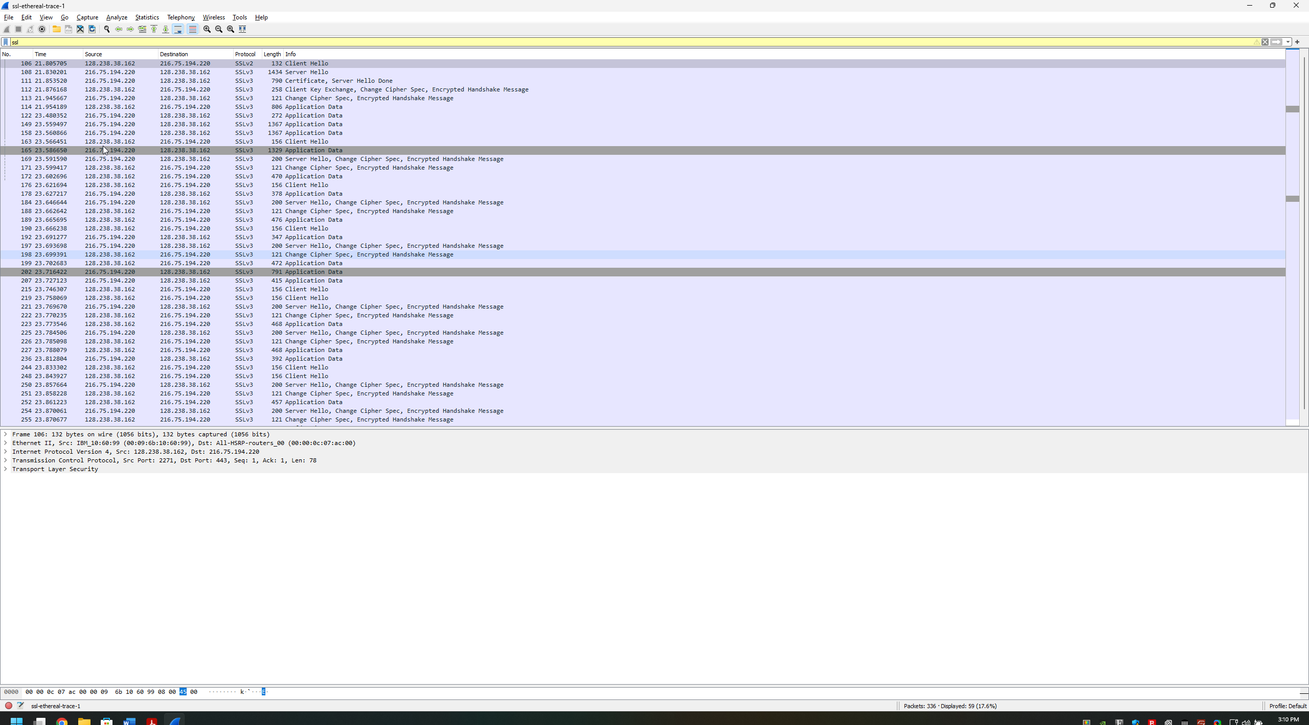

**Part 2**

1. **For each of the first 8 Ethernet frames, specify the source of the frame (client or**

**server), determine the number of SSL records that are included in the frame, and**

**list the SSL record types that are included in the frame. Draw a timing diagram**

**between client and server, with one arrow for each SSL record.**

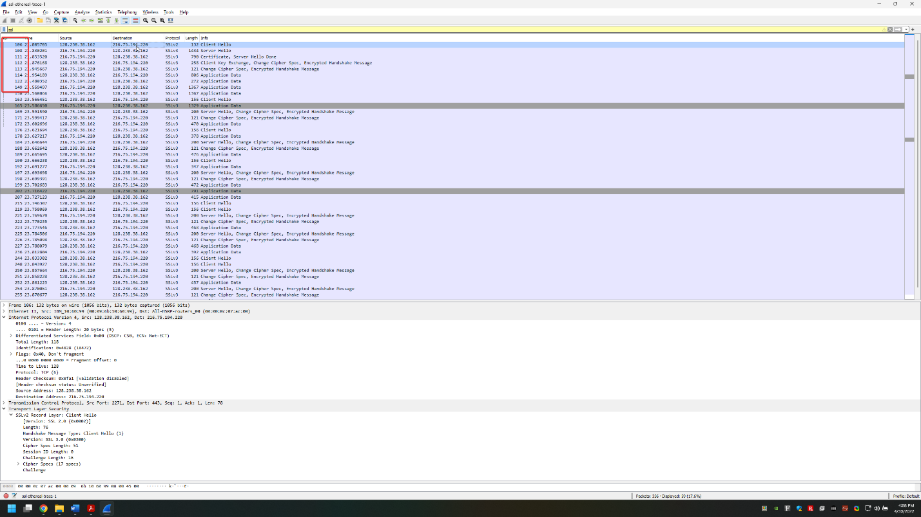

Ethernet frame 1 –

Packet – 106

Source –

Source - 128.238.38.162

Destination - 216.75.194.220

Number of SSL records – 1

SSL record types – Client Hello

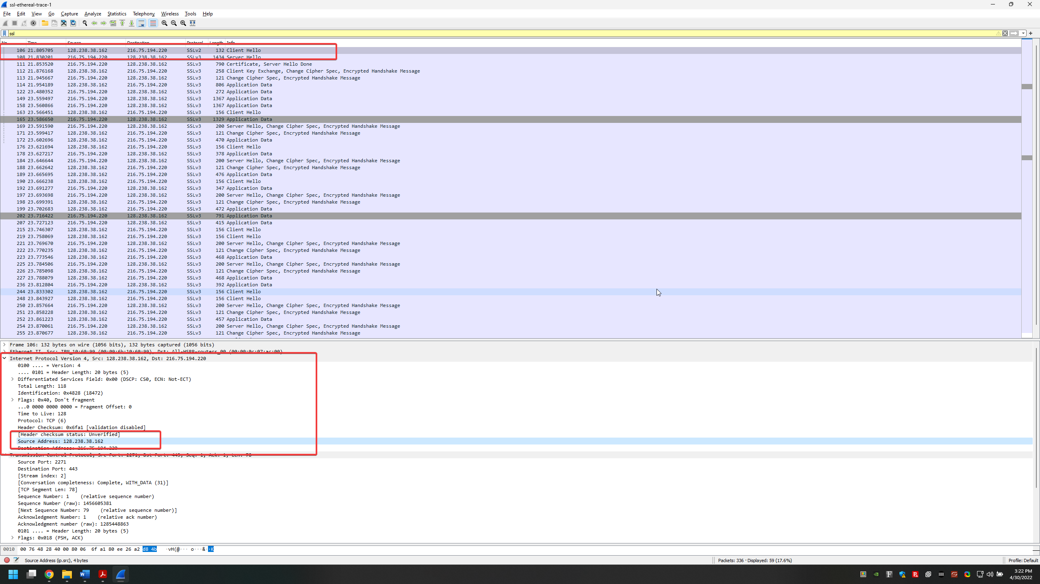

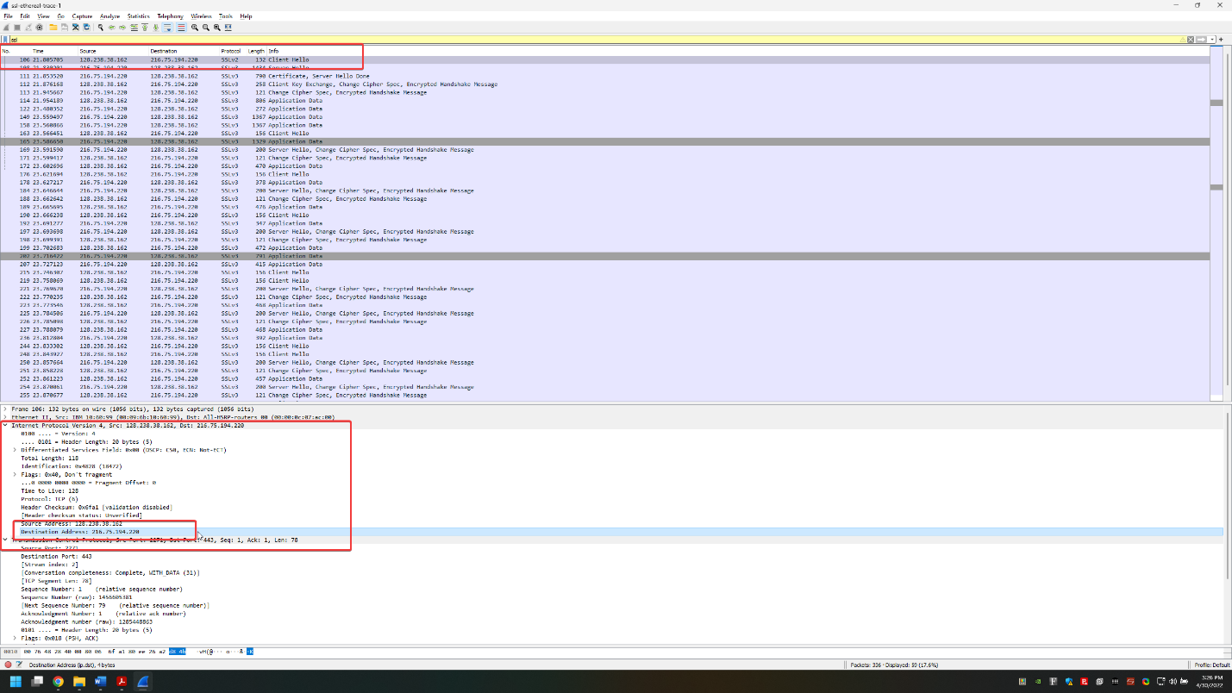

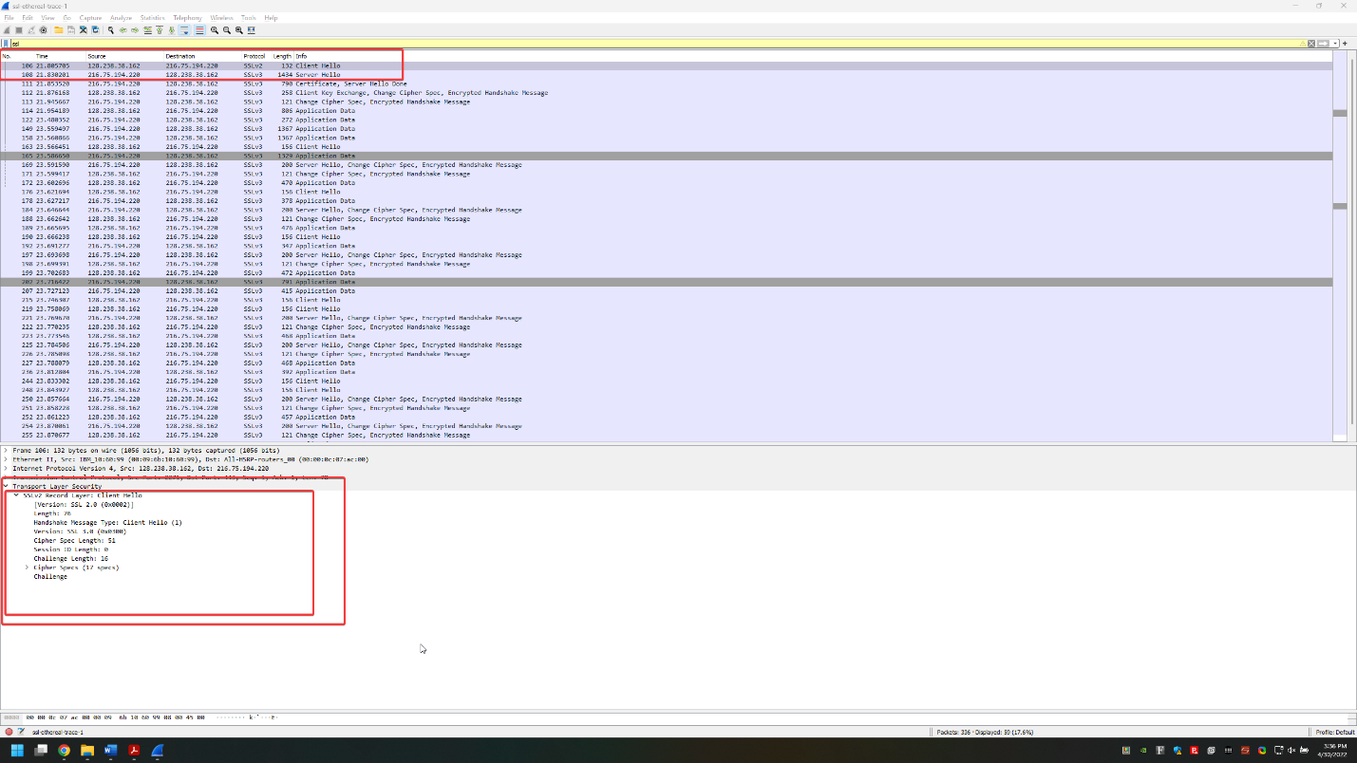

Ethernet frame 2 –

Packet – 108

Source –

Source - 216.75.194.220

Destination - 128.238.38.162

Number of SSL records – 1

SSL record types – Server Hello

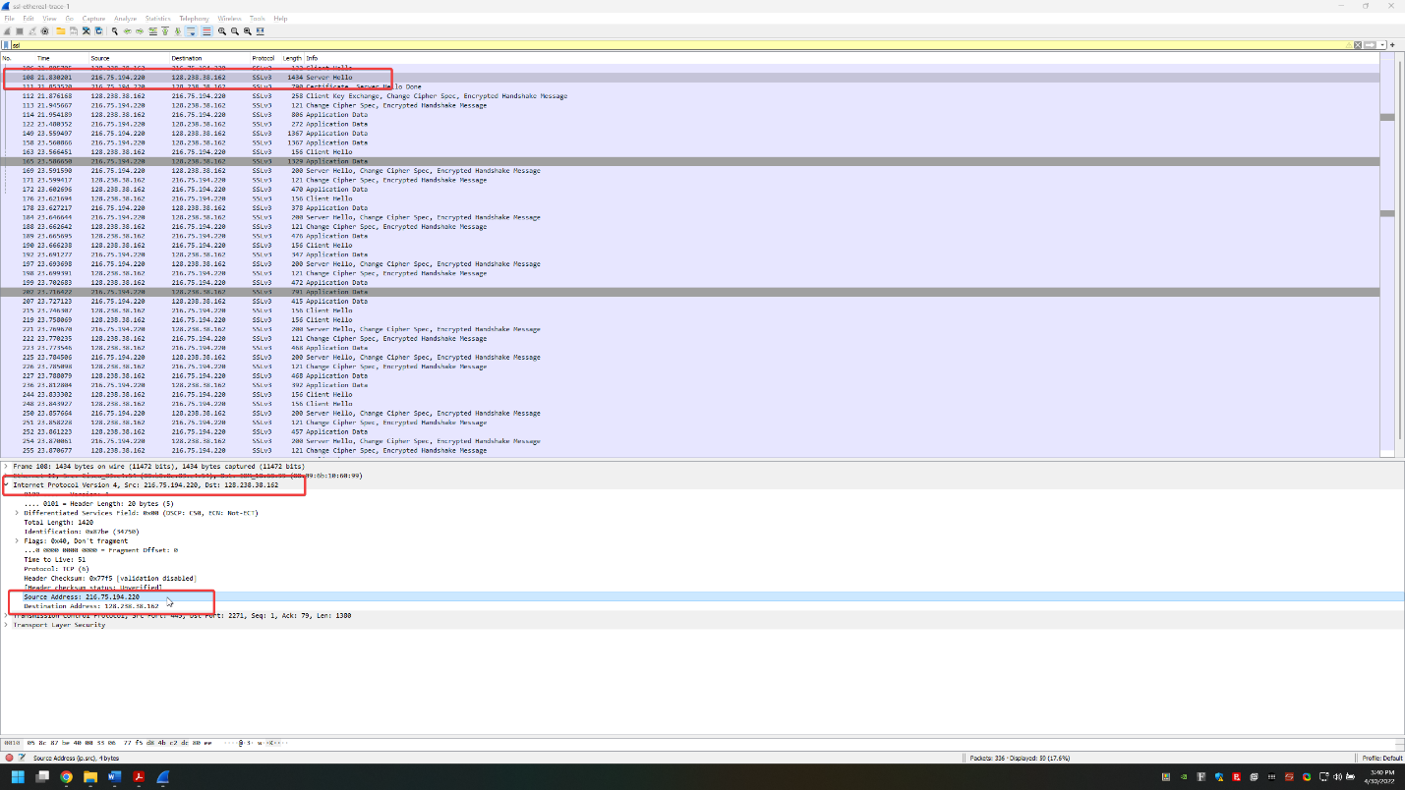

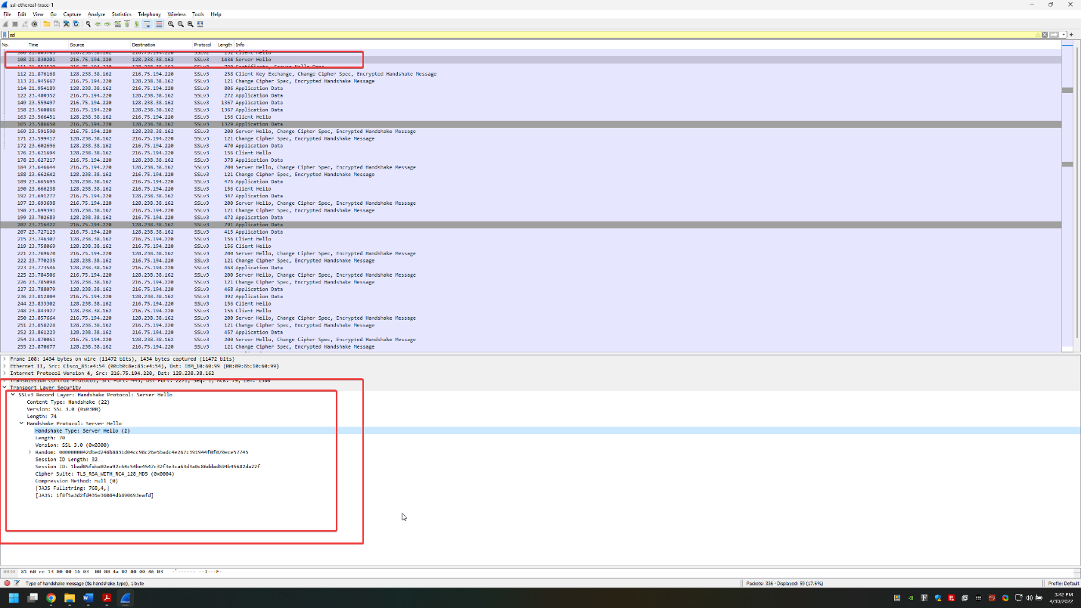

Ethernet frame 3 –

Packet – 111

Source –

Source - 216.75.194.220

Destination - 128.238.38.162

Number of SSL records – 2

SSL record types – Certificate, Server Hello Done

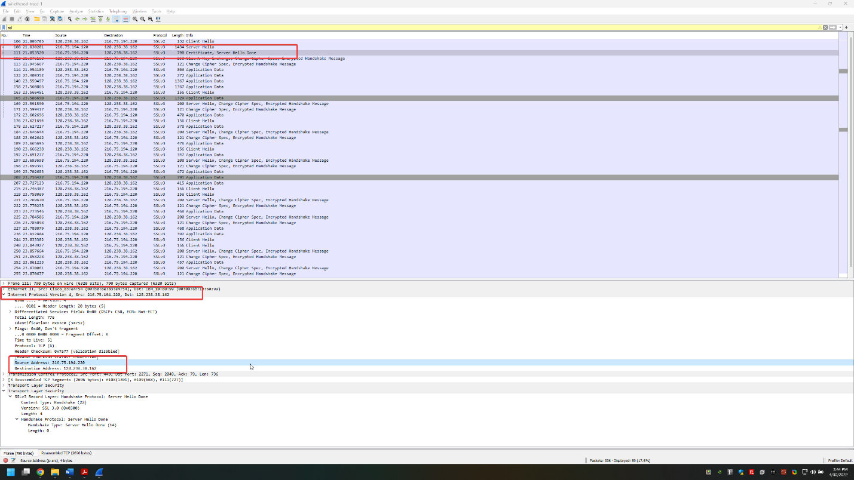

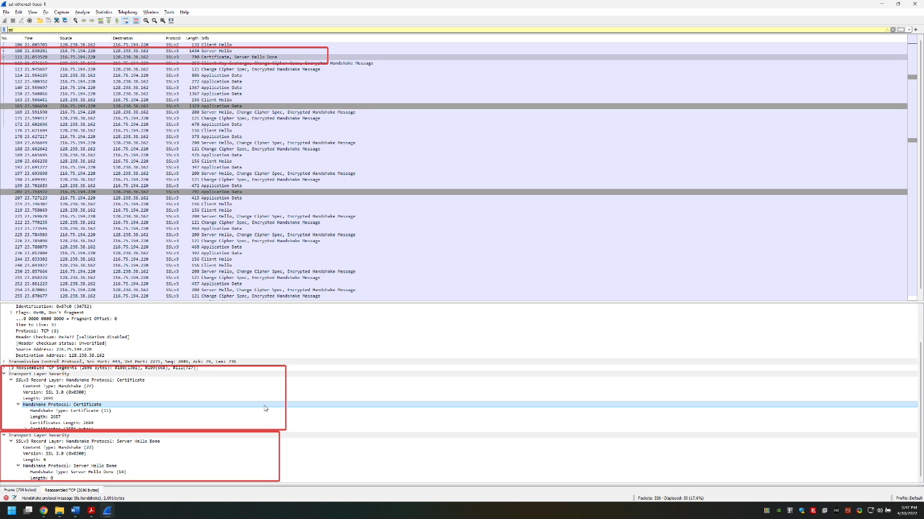

Ethernet frame 4 –

Packet – 112

Source –

Source - 128.238.38.162

Destination - 216.75.194.220

Number of SSL records – 3

SSL record types – Client Key Exchange, Change Cipher Spec, Encrypted Handshake Message

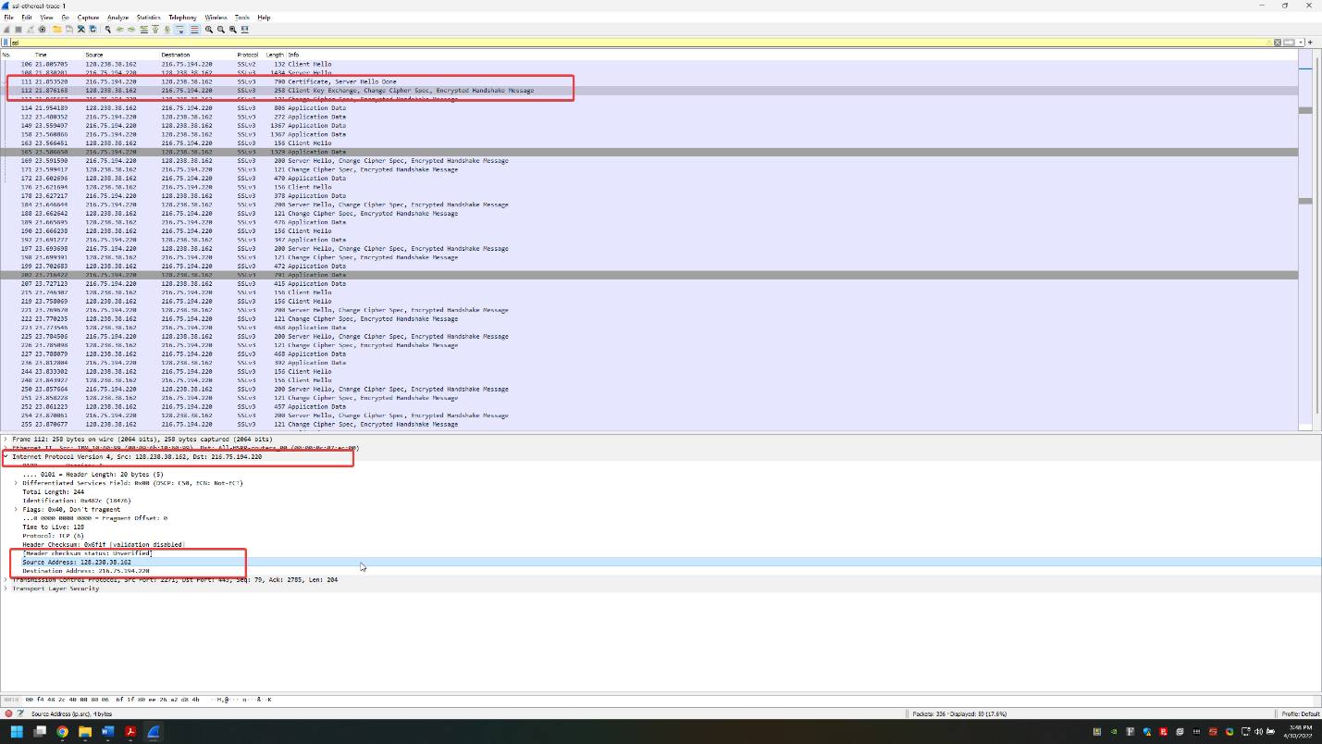

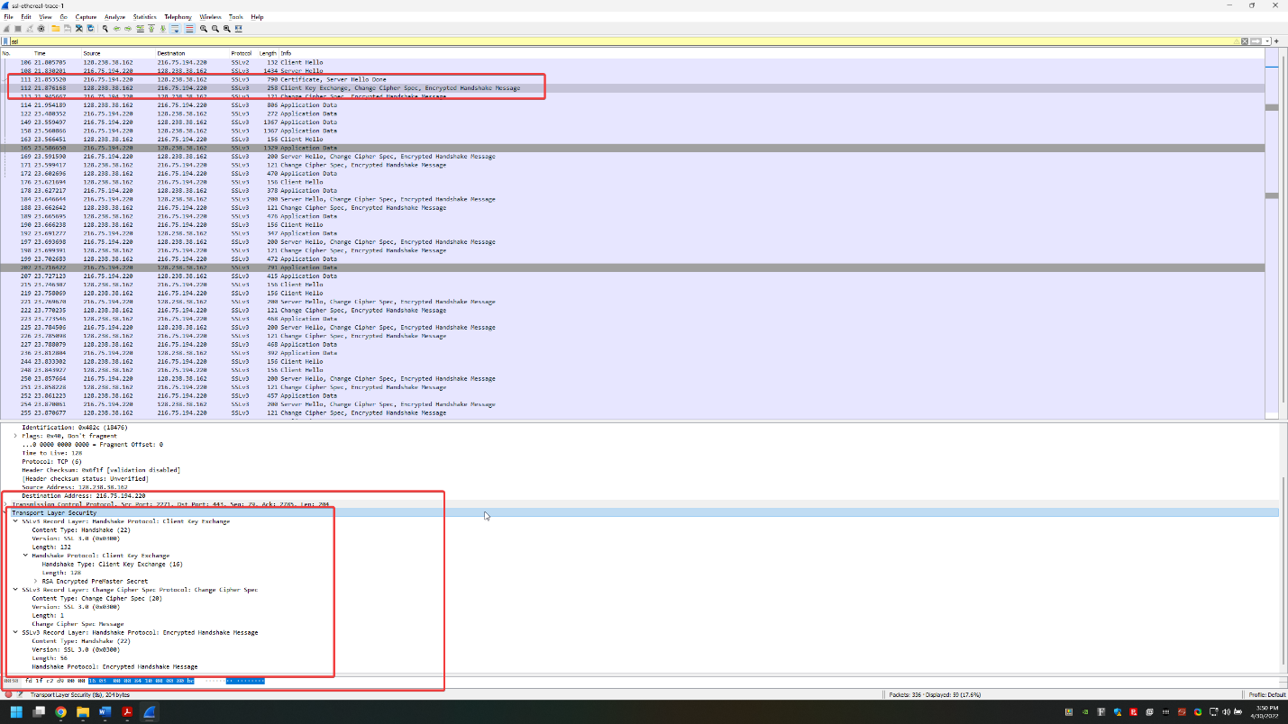

Ethernet frame 5 –

Packet – 113

Source –

Source - 216.75.194.220

Destination - 128.238.38.162

Number of SSL records – 2

SSL record types – Change Cipher Spec, Encrypted Handshake Message

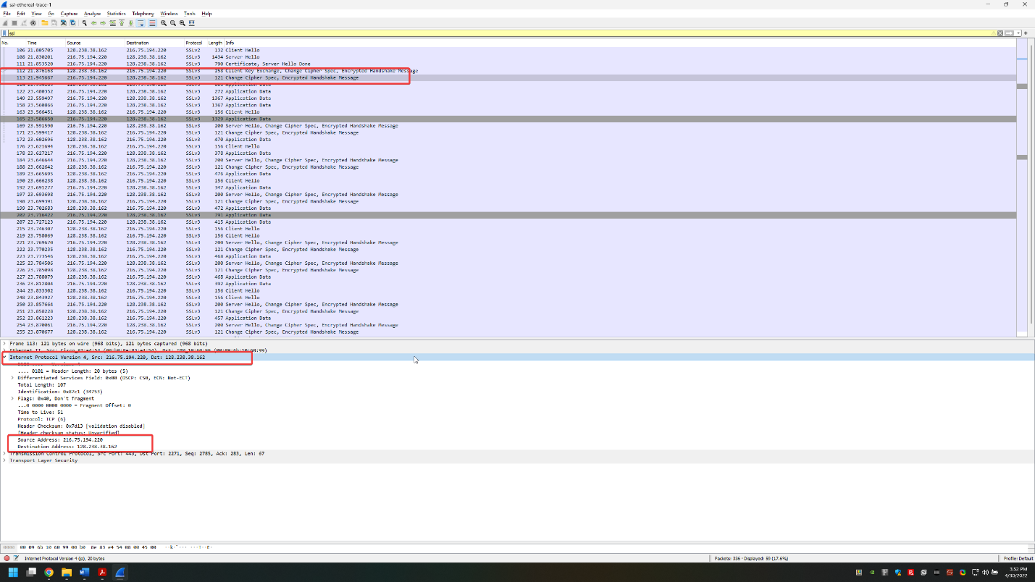

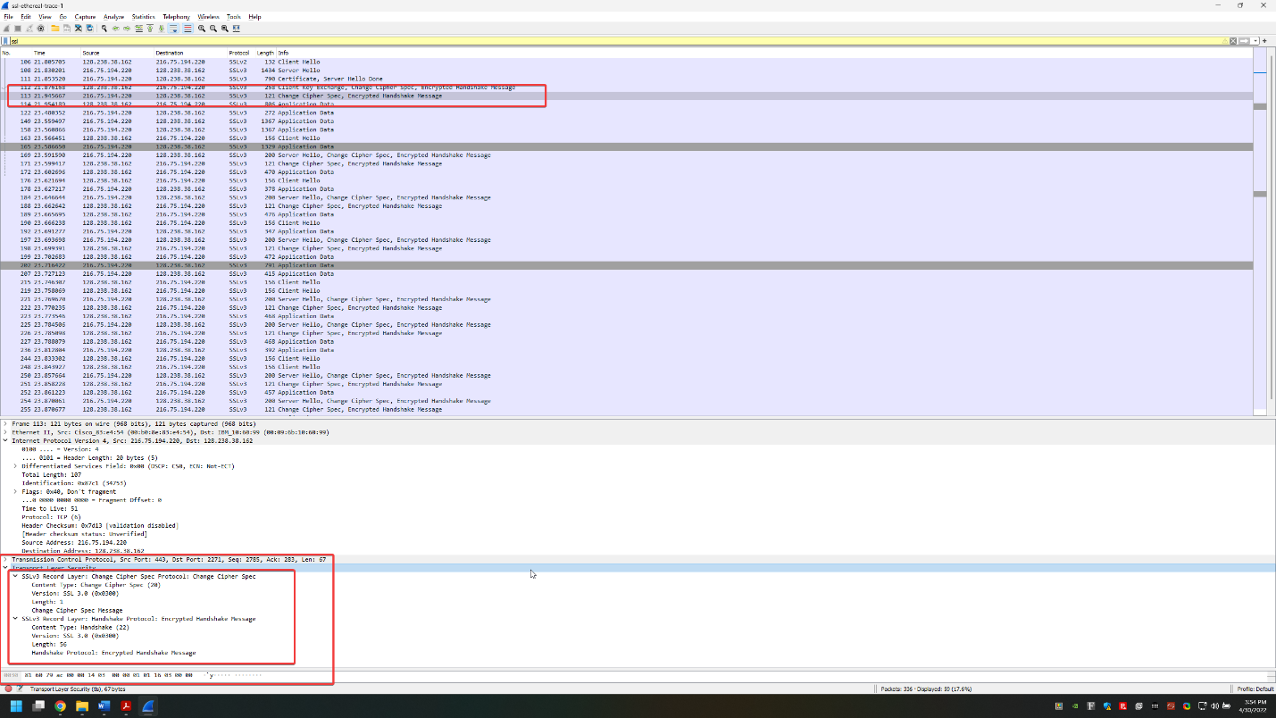

Ethernet frame 6 –

Packet – 114

Source –

Source - 128.238.38.162

Destination - 216.75.194.220

Number of SSL records – 1

SSL record types – Application Data

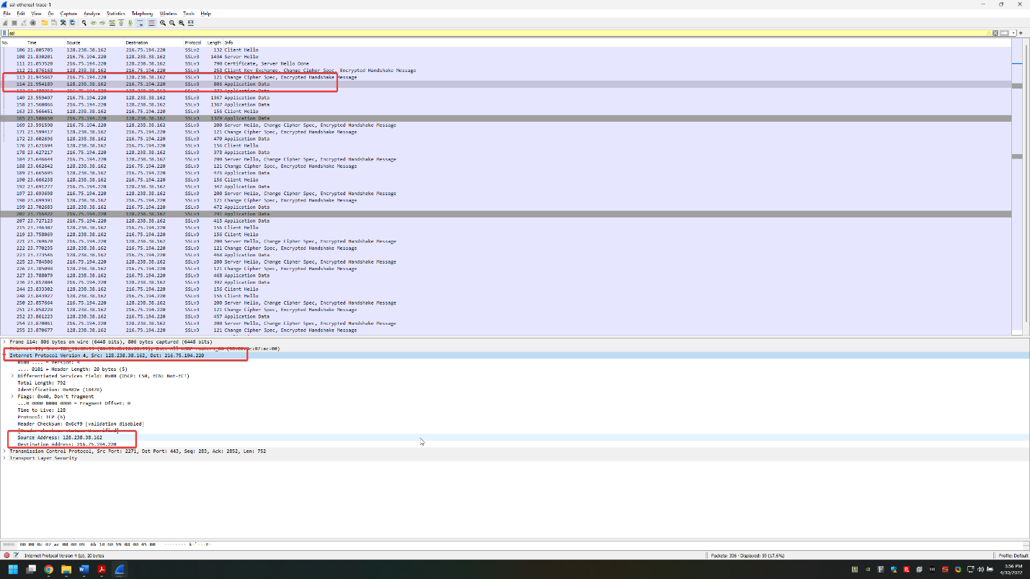

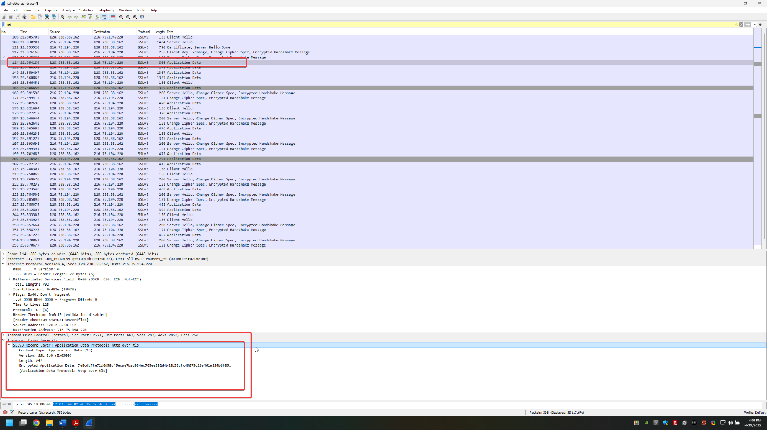

Ethernet frame 7 –

Packet – 122

Source –

Source - 216.75.194.220

Destination - 128.238.38.162

Number of SSL records – 1

SSL record types – Application Data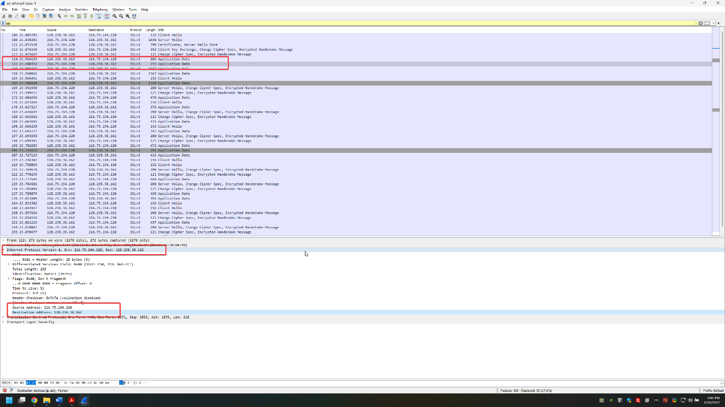

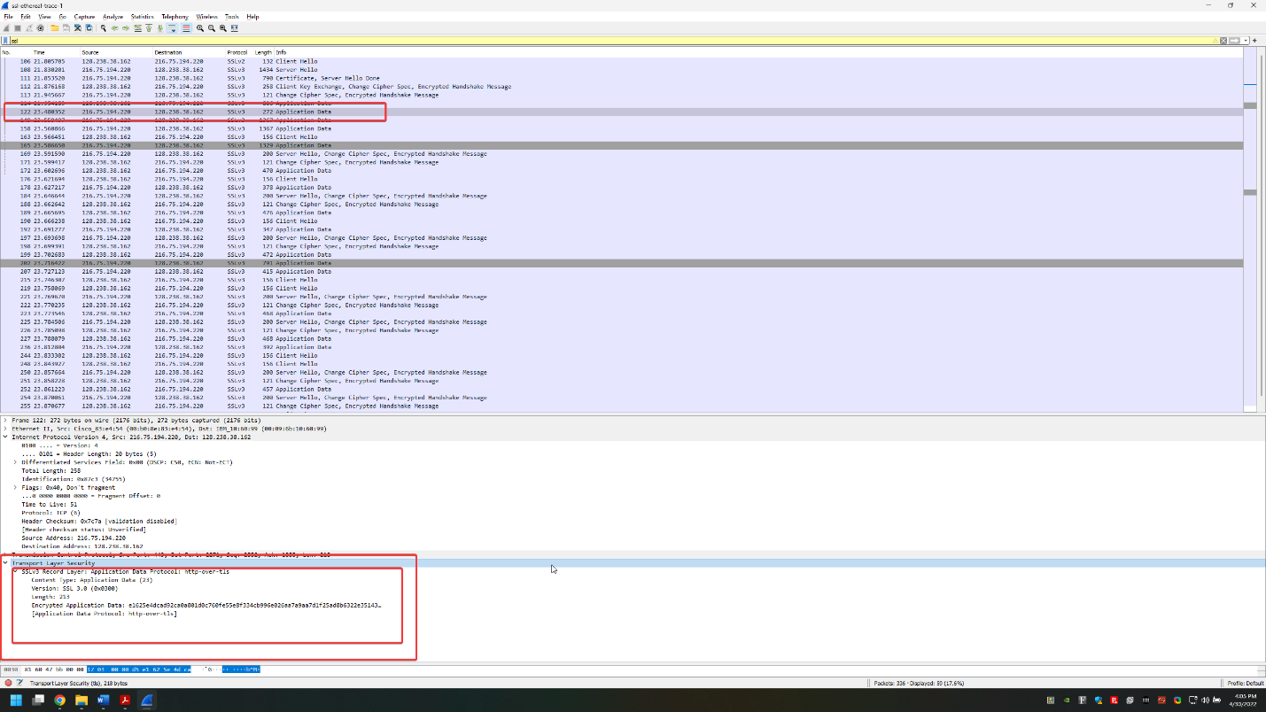

Ethernet frame 8 –

Packet – 149

Source –

Source - 216.75.194.220

Destination - 128.238.38.162

Number of SSL records – 1

SSL record types – Application Data

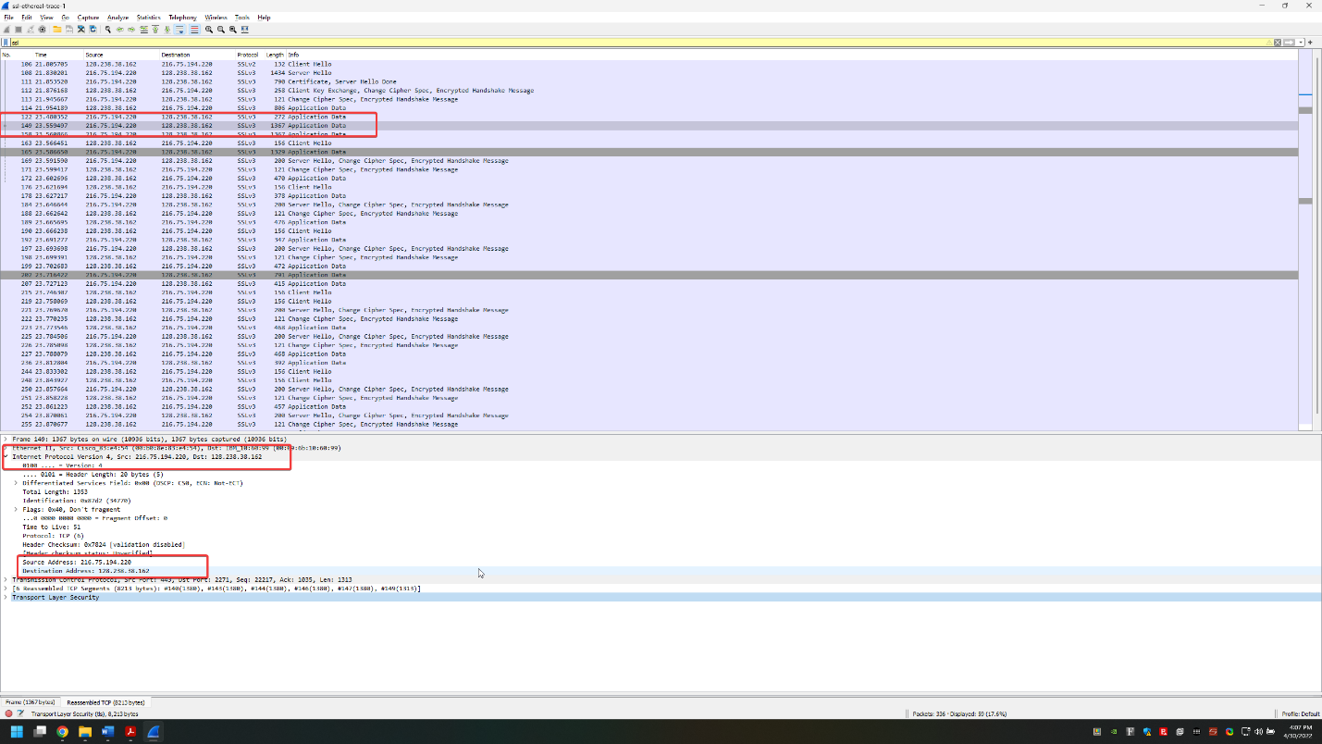

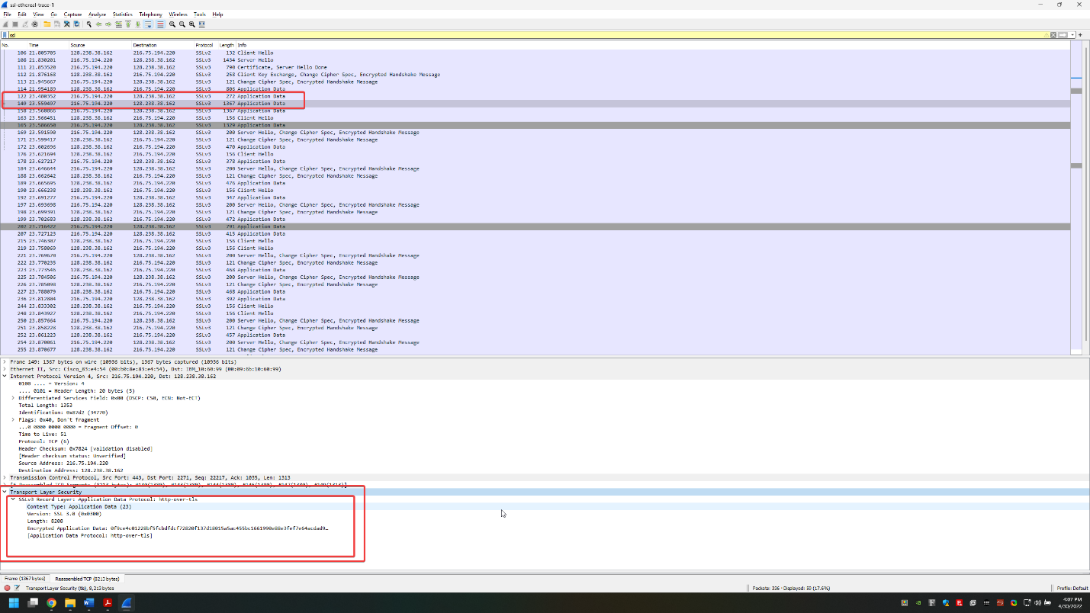

**Diagram:**

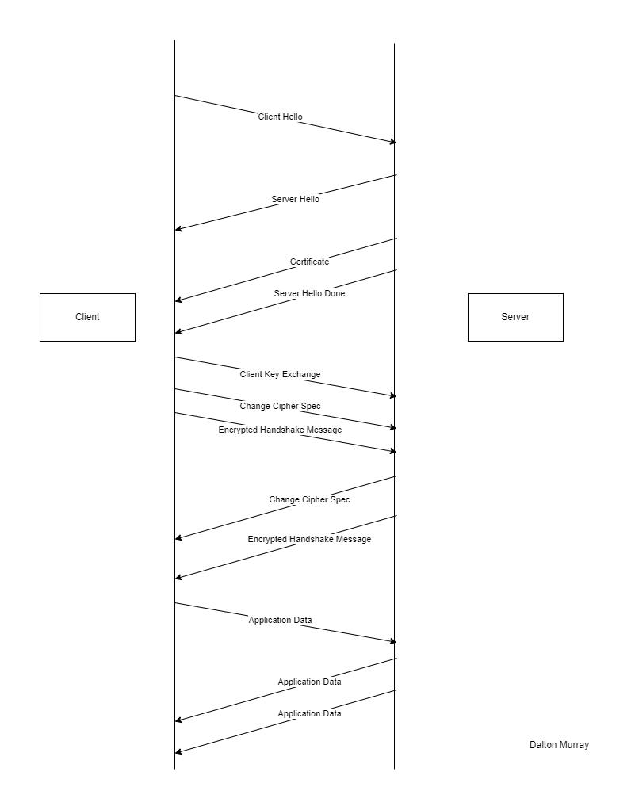

1. **Each of the SSL records begins with the same three fields (with possibly**

**different values). One of these fields is “content type” and has length of one**

**byte. List all three fields and their lengths.**

Content Type – 1 byte

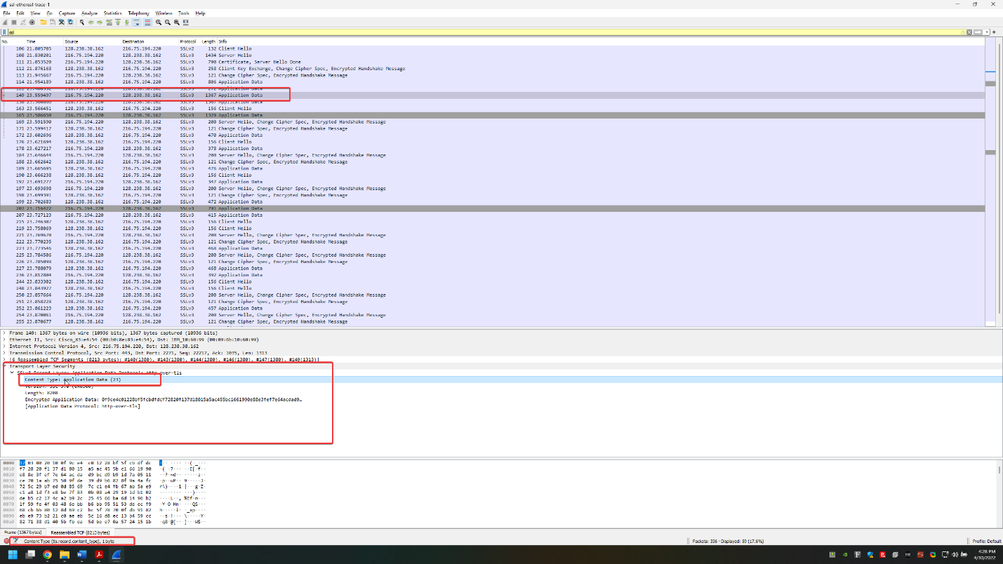

Version – 2 bytes

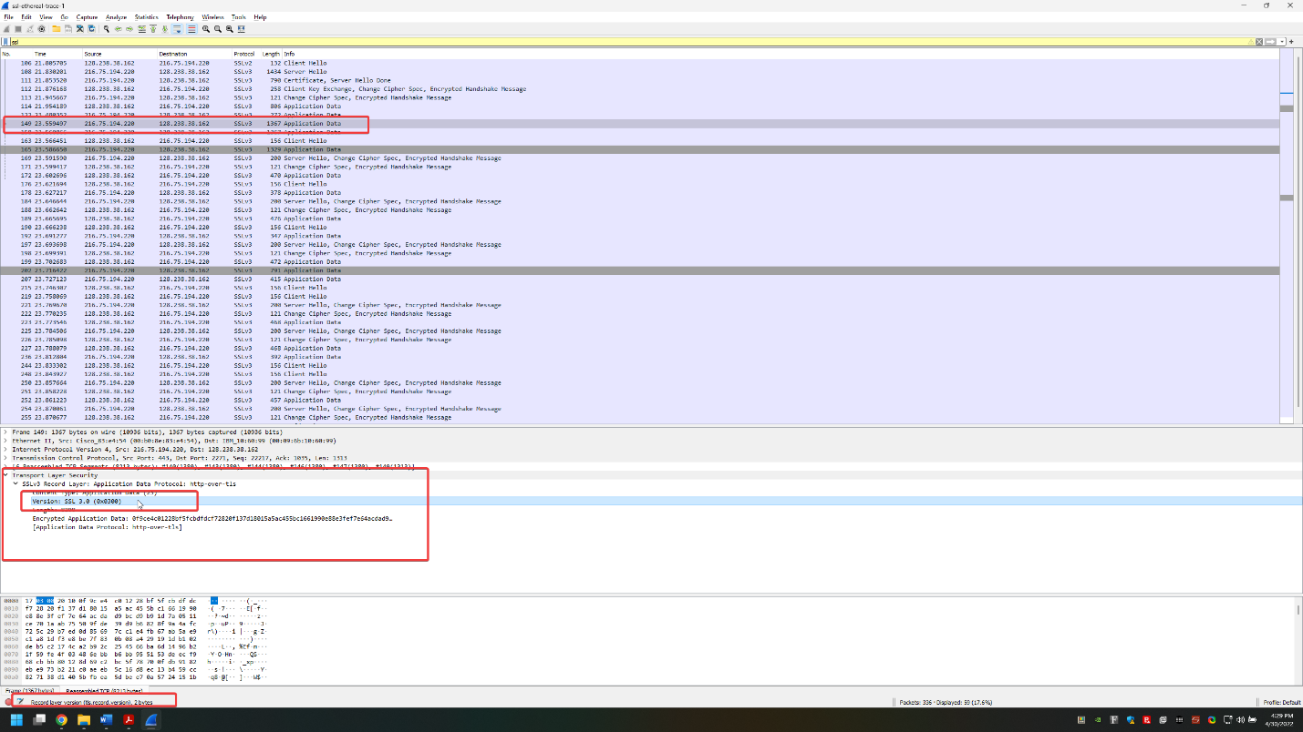

Length – 2 bytes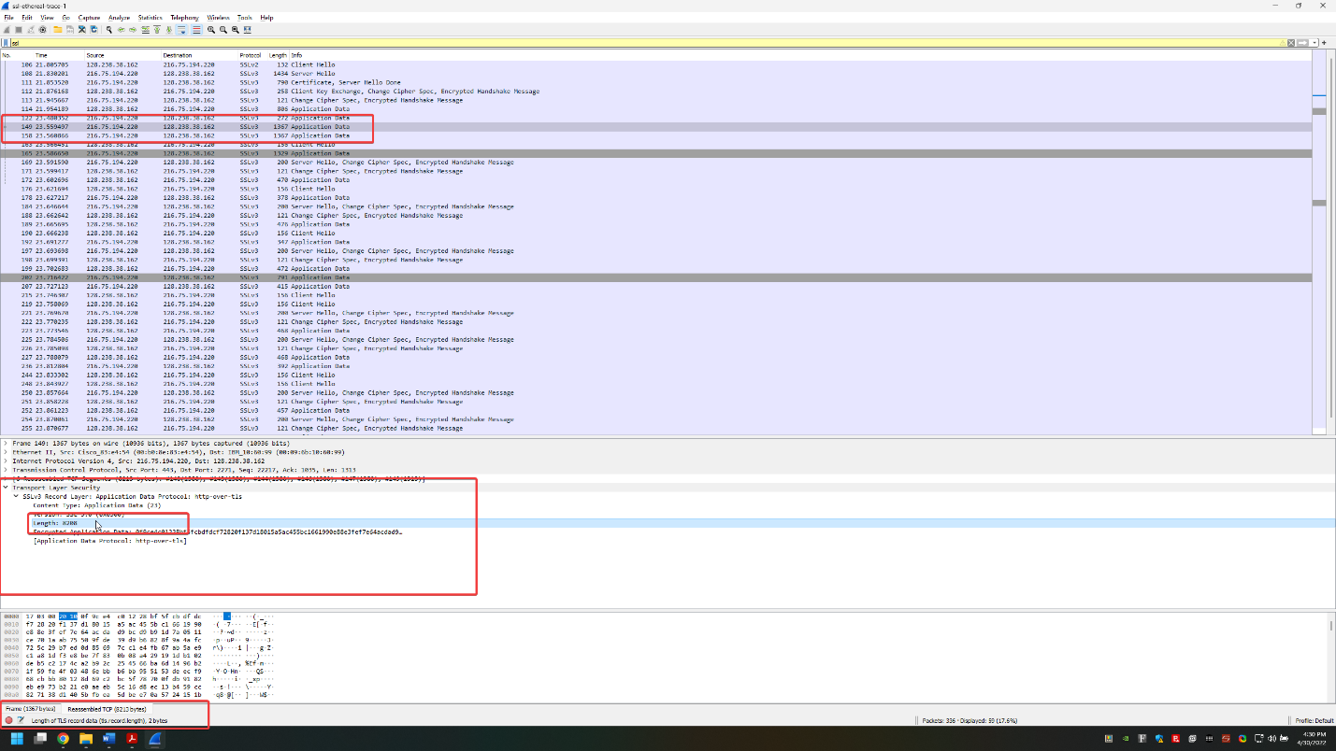

**ClientHello Record:**

**3. Expand the ClientHello record. (If your trace contains multiple ClientHello records, expand the frame that contains the first one.) What is the value of the content type?**

Packet 106 – No content type – Client Hello (1) is closest

Packet 163 - The value of content type is Handshake (22)

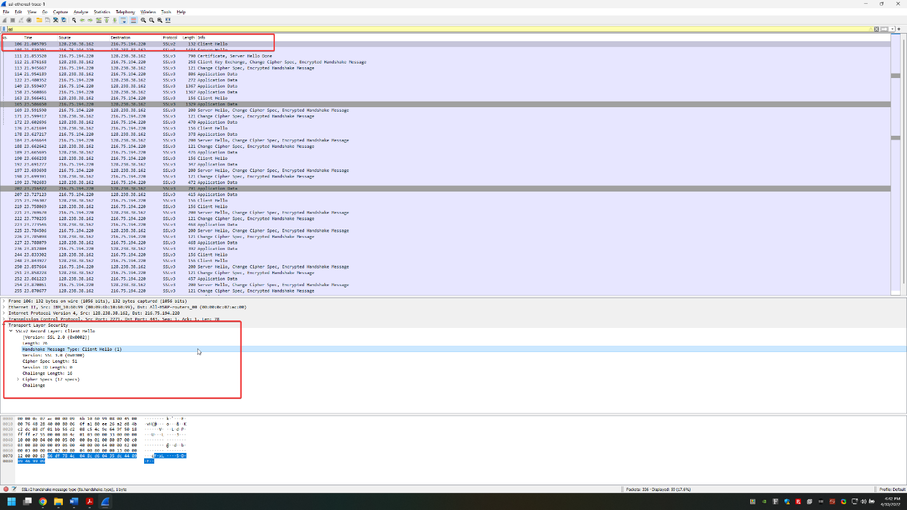

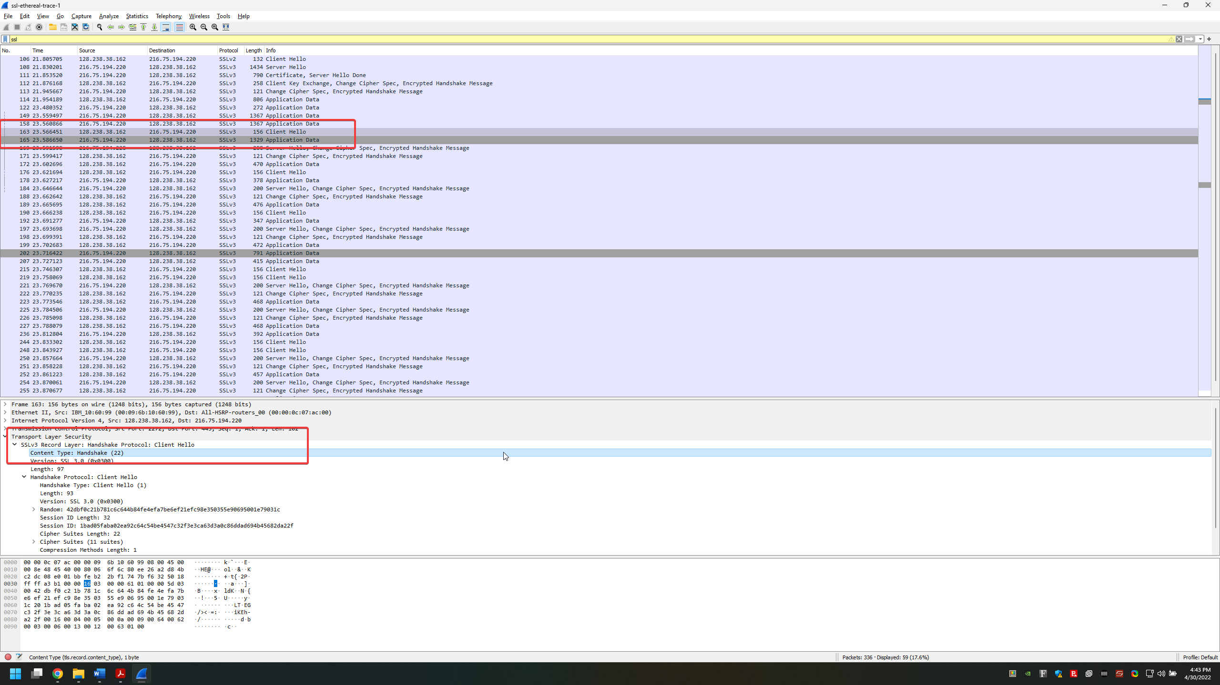

**4. Does the ClientHello record contain a nonce (also known as a “challenge”)? If so, what is the value of the challenge in hexadecimal notation?**

Packet 106 – 66 df 78 4c 04 8c d6 04 35 dc 44 89 89 46 99 09

Packet 163 – This challenge is in the random section, and is not under ‘challenge’, however, if it has to be exactly ‘challenge’ then it does not have a nonce

42 db f0 c2 1b 78 1c 6c 64 4b 84 fe 4e fa 7b e6

ef 21 ef c9 8e 35 03 55 e9 06 95 00 1e 79 03 1c

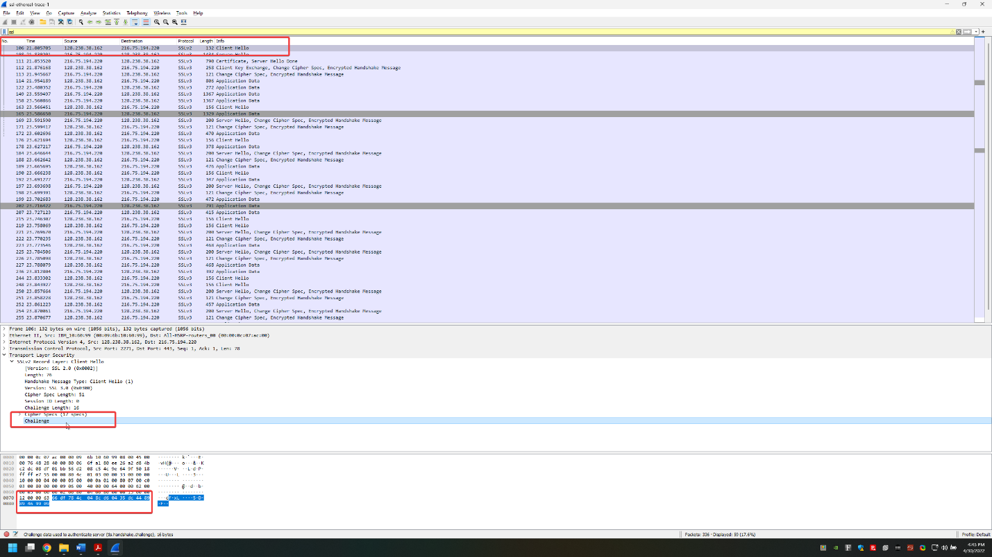

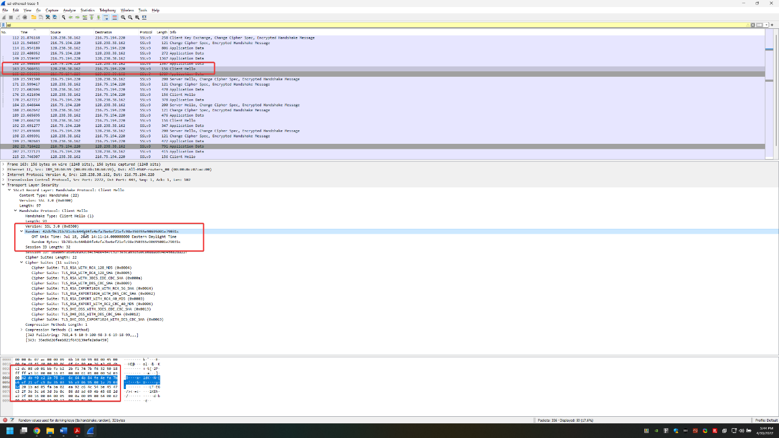

**5. Does the ClientHello record advertise the cyber suites it supports? If so, in the first listed suite, what are the public-key algorithm, the symmetric-key algorithm, and the hash algorithm?**

Packet 106 – Yes it does, it uses RSA with RC4 using MD5

Packet 163 – Yes it does, it uses RSA with RC4 using MD5

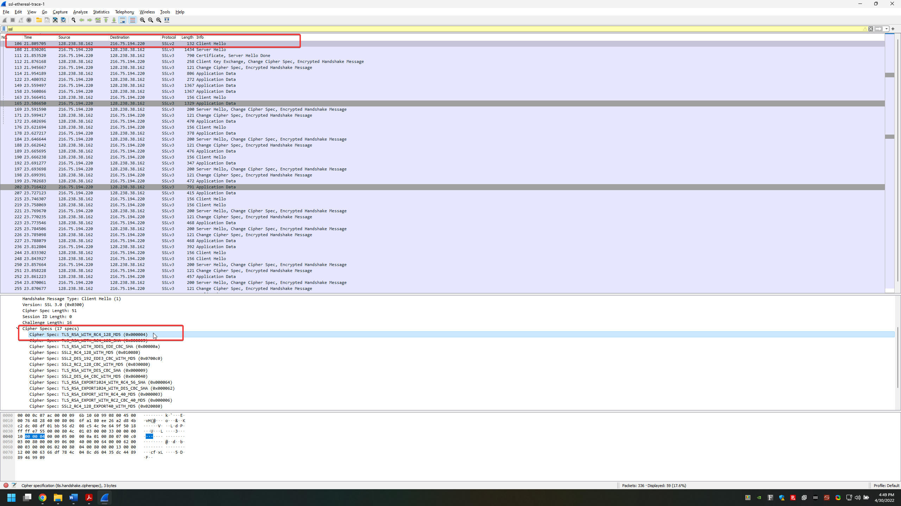

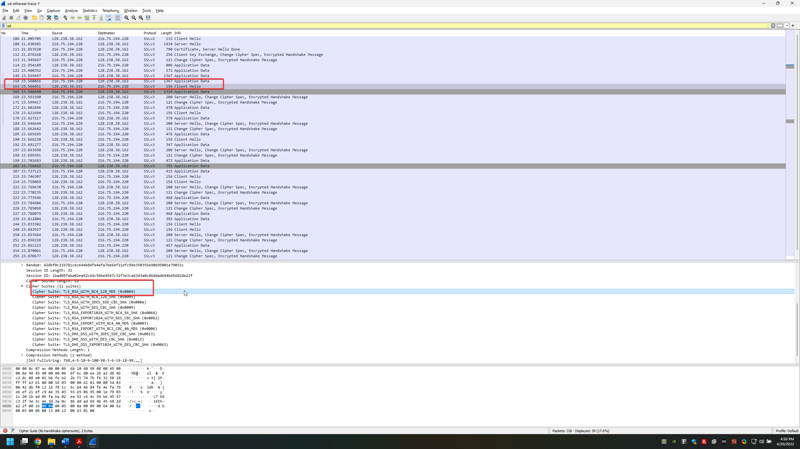

**ServerHello Record:**

**6. Locate the ServerHello SSL record. Does this record specify a chosen cipher suite? What are the algorithms in the chosen cipher suite?**

Yes, it uses RSA with RC4 using MD5

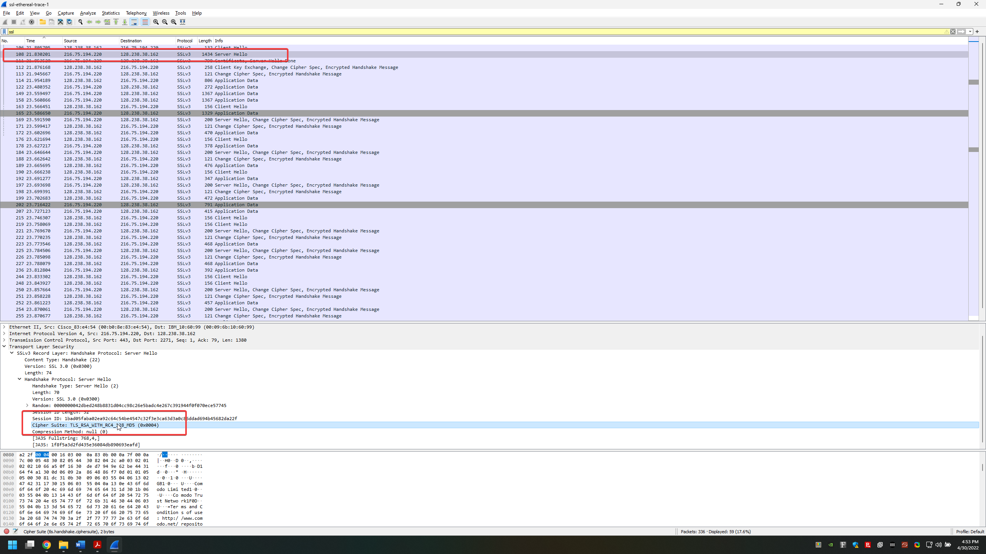

**7. Does this record include a nonce? If so, how long is it? What is the purpose of the client and server nonces in SSL?**

It contains a nonce as Random, however, not ‘challenge’

32 bytes in total

28 bytes for data

4 bytes for time

The purpose of the client and server nonces in SSL is to assist in defending against an attack in the form of a replay/playback attack, and acts as another layer of security.

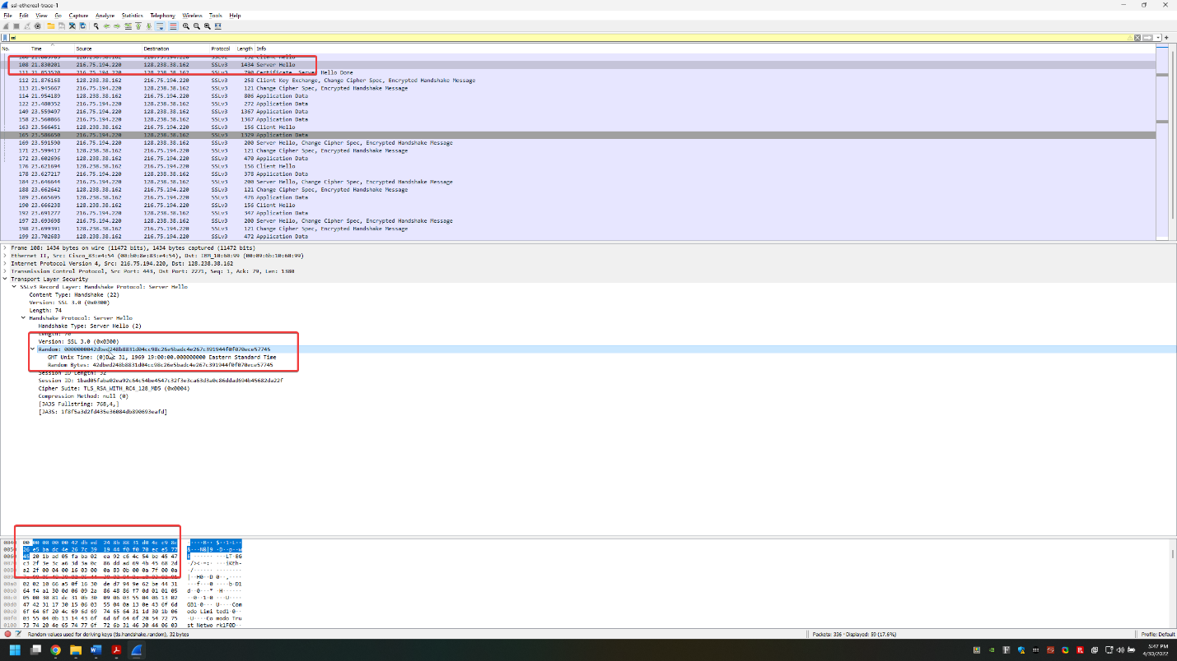

**8. Does this record include a session ID? What is the purpose of the session ID?**

This record does contain a session ID.

The purpose of the session ID is to act as an identifier if the session was interrupted and allows the resumption of the session at a later point using the session ID.

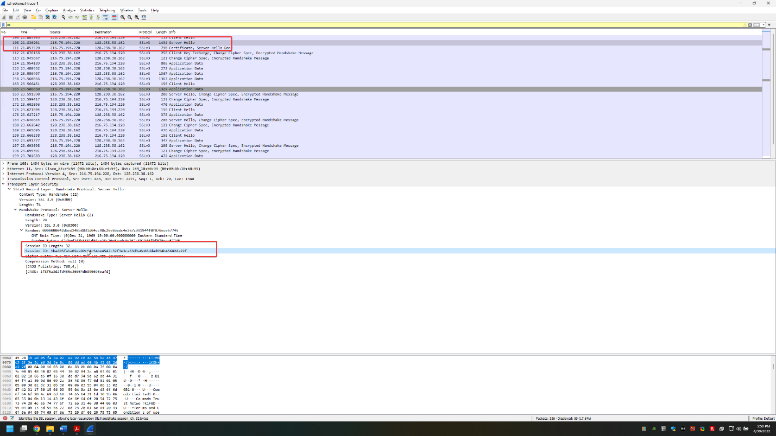

**9. Does this record contain a certificate, or is the certificate included in a separate record? Does the certificate fit into a single Ethernet frame?**

There is no certificate in this record, it is included in a separate record. The certificate does fit into a single Ethernet frame, in this case it is in packet 111.

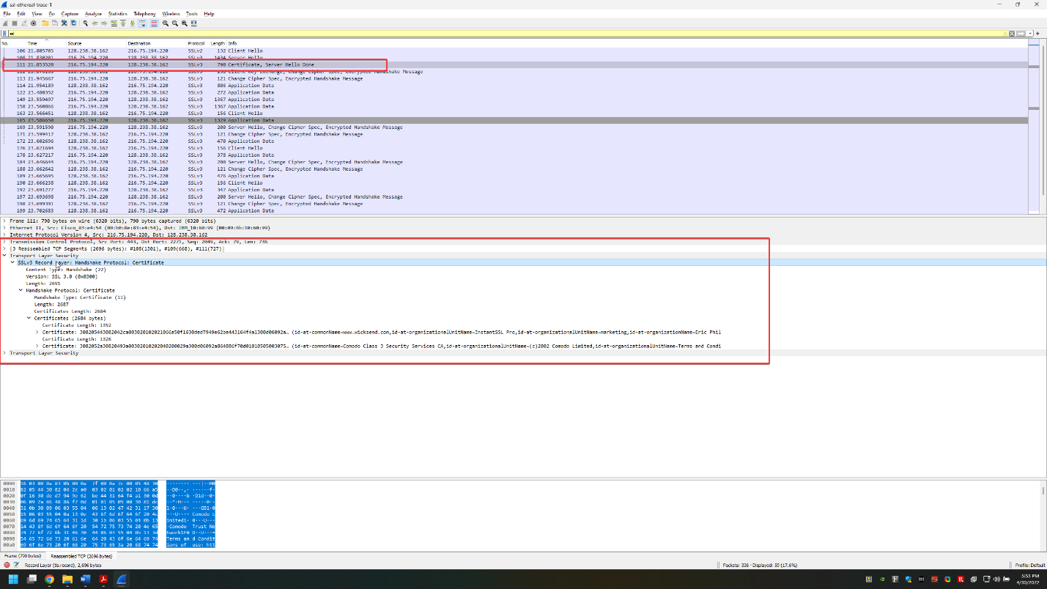

**Client Key Exchange Record:**

**10. Locate the client key exchange record. Does this record contain a pre-master secret? What is this secret used for? Is the secret encrypted? If so, how? How long is the encrypted secret?**

In this case this is packet 112, and it does contain a pre-master secret. This secret is used by the server and the client in order to generate master keys which are then used to create session keys for MAC and encryption. This pre-master secret is encrypted with the server’s public key. This pre-master key is 128 bytes.

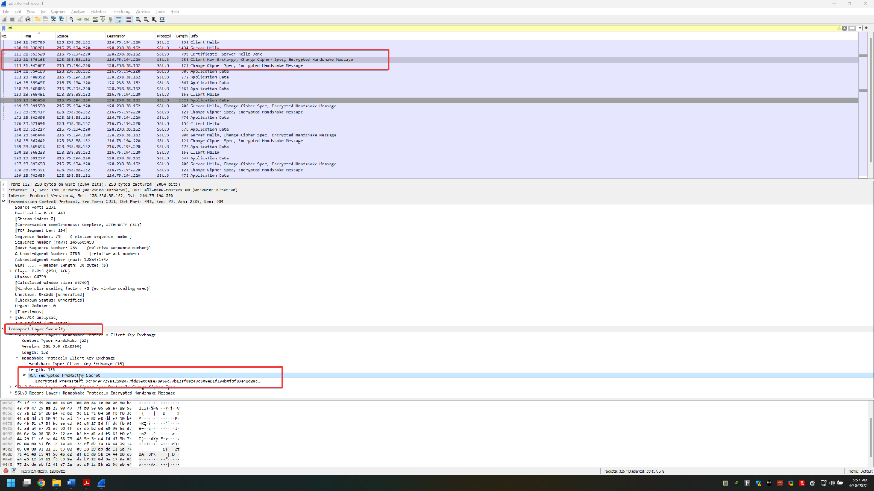

**Change Cipher Spec Record (sent by client) and Encrypted Handshake Record:**

**11. What is the purpose of the Change Cipher Spec record? How many bytes is the record in your trace?**

The purpose of the change cipher spec record is to show that the contents of the next SSL record will be encrypted/change between unencrypted and encrypted. This record is 6 bytes in my trace.

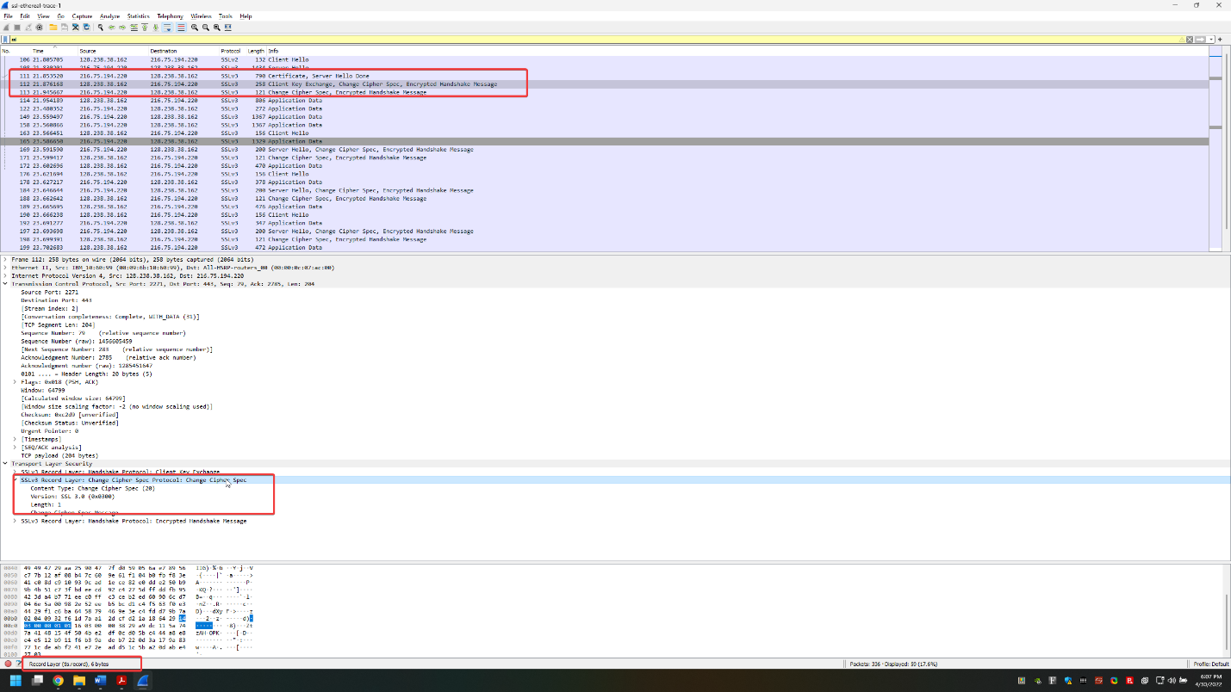

**12. In the encrypted handshake record, what is being encrypted? How?**

In the encrypted handshake record all previous handshake messages from the client are concatenated with the MAC and are encrypted and sent to the server.

**13. Does the server also send a change cipher record and an encrypted handshake record to the client? How are those records different from those sent by the client?**

Yes, the server also sends a change cipher record and an encrypted handshake record to the client. The server’s encrypted handshake is different than the records sent by the client because it contains its own concatenation of the handshake messages.

**Application Data**

**14. How is the application data being encrypted? Do the records containing application data include a MAC? Does Wireshark distinguish between the encrypted application data and the MAC?**

The application data is being encrypted by the usage of symmetric key algorithms, RC4, as this was chosen within the handshakes. Yes, the records containing the application data include a MAC. Wireshark does not distinguish between encrypted application data and the MAC.

**15. Comment on and explain anything else that you found interesting in the trace. How long did it take you to complete this lab? Did you face any challenges? Did you find this lab useful?**

I was curious when doing the trace and looked at the IP of the server, 216.75.194.220, because I downloaded the trace files and found it interesting the server that was reached was from Navisite Opco LLC and that they do managed cloud servicing (<https://www.navisite.com/contact/>). I have no additional comments or feel that I need to explain anything else I found interesting in the trace.

I started this lab at approximately 4:00 pm and it is now 6:28 pm, however, I did have a small break, so it would total around 2 and a half hours.

I faced a couple of challenges in this lab, mostly because of fatigue as it took a while/had a lot of work to do on it, I also had challenges with some of the more written out questions because I didn’t want to look back at things in our book or try to look them up and went off of memory/what I thought they were to be such as the most recent questions.

I find this lab useful for someone not really knowledgeable in Wireshark or are trying to figure out how to read packets on their own, although I also think that people who are in grad school should know how to do basically everything already here except for a few of the questions may need some assistance on.

I pledge that on all academic work that I submit, I will neither give nor receive unauthorized aid, nor will I present another person's work as my own.

Dalton Murray